



Write a Python program to get the Fibonacci series between given two numbers read by user
LAB MANUAL

Disclaimer: The content is curated from online/offline resources and used for educational purpose only
Write a Python program to get the Fibonacci series between given two numbers read by user
Objective:
To create a Python program that generates Fibonacci numbers within a specified range provided by the user. The program will find all Fibonacci numbers that lie between the starting and ending numbers and display them.
Problem Statement:
Write a Python program that prompts the user to input a starting number and an ending number. The program should then generate Fibonacci numbers and store those that fall within the specified range. Finally, it should print the Fibonacci numbers found within that range or indicate if none were found.
Equipment Required:
- Install VS Code - https://code.visualstudio.com/download
- Download Python Installer File - https://www.python.org/downloads/
Prerequisites:
- Basic Computer Skills - Anyone starting to learn computer programming needs basic computer skills.
- Basics of control statements

Procedure:

Task 1: Implementation to get the Fibonacci series between given two numbers read by user
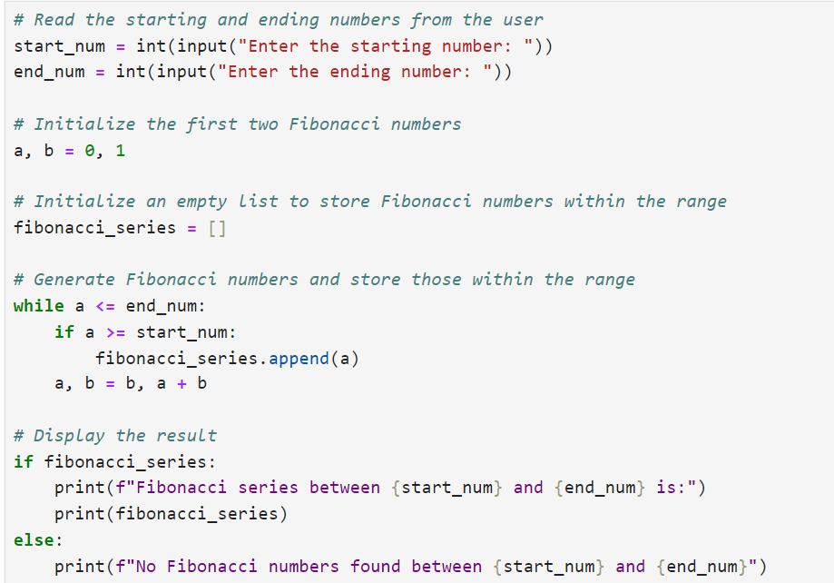
Output:
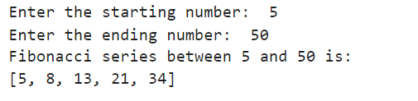
the program generates Fibonacci numbers between 5 and 50 and outputs the list [5, 8, 13, 21, 34]. Note that the Fibonacci number 55 is not included since it exceeds the upper limit of 50.

